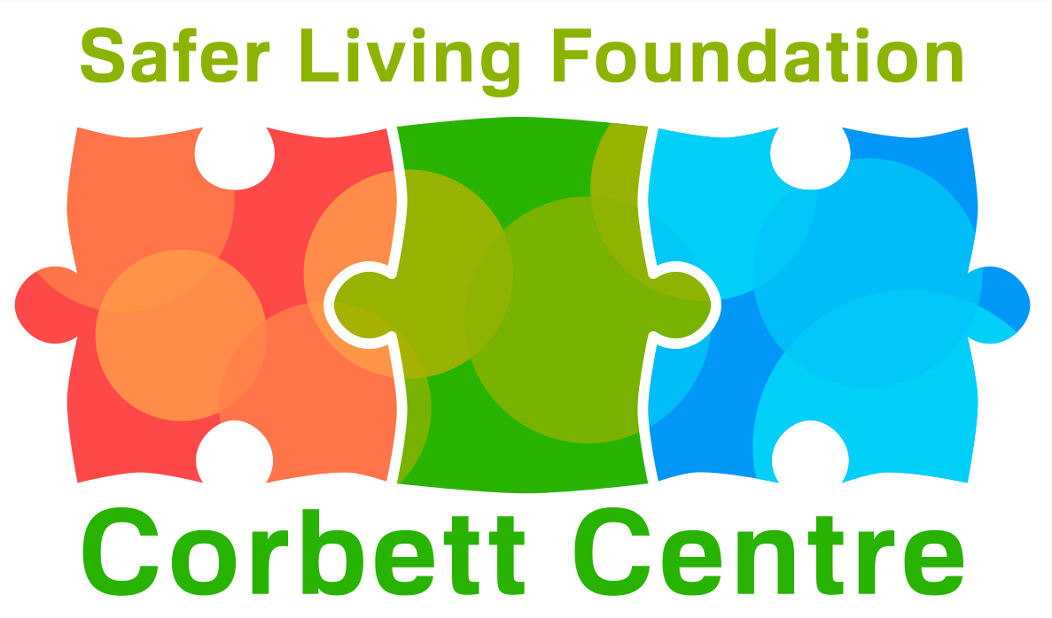
Safer Living Foundation
The Corbett Centre: Service User referral form
To enable us to assess your suitability to attend the Corbett centre, please complete this form as fully as possible and return to:david.potter@ntu.ac.uk
Proposed Service User
Self-Referral / Mental Healthcare Referral
Your name

Date of Birth
Gender (optional)
Religion (optional)

Date of Referral

Your Address

Telephone

E-mail

Date of Release from Prison (if applicable)

Please name a referee whom we can contact to confirm your details. This can be agency staff eg: police, health care professional or mental health teams staff.

Their relation to you.

Their Address

Telephone

E-mail

Do you give permission for your records to be accessed for the purpose of assessing your suitability to attend the Corbett Centre? Including but not limited to:  - Psychology Reports.  - Risk Assessment Information.  - Probation Reports and License Conditions.  1. Your personal data will be stored securely and accessed only by SLF staff  2. It will be used to assess your suitability for attendance at the CC and ongoing risk management  3. Your data will be held consistent with the requirements of the GDPR.  Do you give permission for Centre staff to contact you by telephone  Please sign and date to indicate consent for Corbett Centre staff to have access to this information.  If you are unwilling to allow us access to this information we will be unable to offer you a place at the Corbett Centre. | YES NO  YES NO  Sign:  Date:
Have you ever harmed or been abusive to any staff or volunteers who may have supported you in the past?
Are there any specific individuals (excluding victims) that you are prohibited from having contact with?

Your Referral Status
Please let us know if any of the following apply to you. | Yes /No | Details  (E.g. start & end date, conditions etc.)
Remand

On Bail
On License

Arrested – awaiting charge
Charged – awaiting sentencing

Community Rehabilitation Order

Sexual Harm Prevention Order

Sex Offender Registration

Are you subject to MAPPA
(if yes please specify level)

Your Conviction History
Please give details of any current / previous convictions for a sexual offence.
(Please include dates, offence, court, and sentence)

If none – write None.

Any other convictions?

If none – write None.

Your Personal Circumstances
Do you have any requirements with regard to reading / writing or learning?

Do you have any mental health issues that you think we should know about?

Do you have any problems with substance misuse?

Do you have any disabilities or mobility issues?

Do you have any self-harm or suicidal tendencies?

Is there anything else you think we need to know about you in order to better support you?

Agencies who may be working with / supporting you.
Please give a contact name, address, telephone number and e-mail if applicable. We may contact any of the agencies you list in order to help us make an informed decision about how we may best support you.
Offender Manager
MOSOVO Officer
MAPPA Contact
Social Care / Health care Professional
Any Other Support (Family – friends etc…)

Thank You: Please return to: david.potter@ntu.ac.uk

